**Description**

**I. Product layout:**

■ Open way: 3D face recognition,fingerprint, password, IC card, key, wishome app and other ways to open the door,Bring you different experience to open the door;

■ Face recognition: 125°infrared light face recognition, fast unlocking, can also be used at night, wide angle, and can also be used by children with low height. It is forbidden to use photos, molds, etc. to unlock, no need to worry about false unlocking by bad guys.

■Fingerprint: Using advanced semiconductor sensor, 360-degree recognition Angle, wide range of fingerprint collection,High resolution, effectively prevent false fingerprint;

■ Password: Adopt stylish and advanced touch-screen key technology, which can add 12 digits before and after the correct password, effectively prevent many peers when the password embarrassment;

■ Dual verification mode: fingerprint, password and card can be set in pairs to verify unlocking, only after setting,must need two users at the same time verification can open the door, suitable for special occasions;

■ User management: administrator enjoys the highest authority (ordinary users can only open and close the door operation), can edit setting the lock, the number of administrators is 9 (can be fingerprint, password, card), the total capacity is 300pcs;

■ Alarm function: The machine has anti-warping alarm, low pressure alarm, trial and error alarm;

■ Standby power supply: when the battery runs out, use 5V mobile power supply to emergency power supply for the door lock;

**Notes:**  1. When fingerprint collection, finger strength is moderate, do not vigorously pressure, to prevent the fingerprint collection head scratch;

1. Battery use time should not be too long, it is generally recommended to recharge after 3 months, otherwise battery leakage will damage the smart lock; 3. The lock use 8.4V high performance lithium battery, when the first prompt "low power, please replace the battery", according to different battery capacity, can also open the door about 100 times, at this time should be charged in time.
2. Face/fingerprint/card/password input error 5 times in total after the alarm, the device sounds alarm, the door lock can not be used within 90 seconds; ■ Initialization operation: use the needle, press the hole in the middle of the rear panel lock/lock button, hold for 5 seconds, the voice prompt "initialization successful", the factory password is "123456",then you can open the door, after entering the administrator information, the factory password "123456" will be automatically deleted

**2.Access door lock function**

*—Return key, exit key, delete key

#—Confirm key, enter key, repeat voice broadcast

1. Press *# to Wake up screen in initialization state
2. factory password "123456"

(1)Firstly, Press “* + #”, then listen to voice prompt “ select the number key to next step”, then input 123456, finally press “#” to verify

(2)Voice prompt “successfully”

**3.Main menu**

Wake up the screen, press“*#”to on keypad to verify the enrolled administrator. You can enter the main menu. Then select the number key to next step

|  |  |  |  |  |
| --- | --- | --- | --- | --- |
|  |  |  | 1.face | 1.Ena Dual vrf |
|  |  |  | 2.fingerprint | 2.Dis Alarm |
|  |  |  | 3.password | 3.Dis Get close |
|  |  | 1.Add User | 4.card | 1.Volume up |
|  |  | 2.Delete user | 1.func setting | 2.Volume down |
|  |  | 3.Option | 2.volume setting | 1.Chinese |
|  |  | 4.Add admin | 3.language | 2.English |
|  |  |  | 4.more setting | 1.Time setting |
| 1.Lock setting |  | 1.Add Module |  | 2.Rrecord query |
| 2.App setting |  | 2.Delet Module | Wireless pairling | 3.Init system |
| 3.Install |  |  |  |  |
|  |  | 1.Motor DIR | 1.Forward |  |
|  |  | 2.RTN time | 2.Reverse |  |
|  |  | 3.Set close time |  |  |
|  |  | 4.Delay lock |  |  |

**4.Function menu instruction**

**4.1 Add users and administrator**

(1)Add face

Put your face toward the lock,and follow the prompt “lock up,lock down,turn left, turn right”,after the prompt“successfully”， press

“*” to retreat to the system menu.

(2)Add fingerprint

Put your finger on the bottom of sensor, and follow the prompt “press again”. You can consecutively add fingerprint after the prompt“successfully”， press

“*” to retreat to the system menu.

(3)Add password

Firstly, input six to eight digital, then press “#” to verify, finally input again the same code. After you finish this, password is recorded successfully.

(4)Add Card

Place the card near the antenna reception area, listen to the prompt “successful”

**4.2 Delete user**

(1)Verify Delete

|  |  |  |  |  |  |  |
| --- | --- | --- | --- | --- | --- | --- |
| 1.Add user |  |  |  |  |  |  |
| 2.Delete User | Press 2 | 1.Verify Delete | | Press 1 Input the fingerprint | | |
| 3.Option |  | 2.Delete by ID | | Or Card record | | |
| 4. Add admin |  |  |  |  |  |  |

If you want to delete the fingerprint, code and card, just input these information. If you want to delete face record, just stand in front of lock.

**Tips**：The record can be deleted consecutively, please press “*” to exit.

**4.3 Install setup** (1)Door Direction setup

|  |  |  |  |  |  |  |
| --- | --- | --- | --- | --- | --- | --- |
| 1.Lock setting |  | 1.Mortor DIR |  |  |  |  |
| 2.App Setting | Press 3 | 2.RTN time | Press 1 | 1.Forward |  |  |
| 3.Install |  | 3.Set close time |  | 2.Reverse |  |  |
|  |  | 4.Delay lock |  |  |  |  |

Tips: 1. Hammerhead at the right of door, door direction is left.

2.Hammerhead at the left of door, door direction is right.

(2)Automatically locked

|  |  |  |  |  |  |  |  |  |  |
| --- | --- | --- | --- | --- | --- | --- | --- | --- | --- |
| 1.Lock setting |  | 1.Mortor DIR |  | |  | | |  |  |
| 2.App Setting | Press 3 | 2.RTN time | Press 4 | | enable automatic | | |  |  |
| 3.Install |  | 3.Set close time |  | | locking | | |  |  |
|  |  | 4.Delay lock | |  | |  |

**4.4 APP Setting**

|  |  |  |  |  |  |  |
| --- | --- | --- | --- | --- | --- | --- |
| 1.Lock Setting |  |  |  |  |  |  |
| 2.App setting | Press 2 | 1.Add Module | Press 1 | Wireless pairing | |  |
| 3.Install |  | 2.Delet Module |  |  | |  |
|  |  |  |  |  |  |  |

**4.5 Restore factory setup**

|  |  |  |  |  |  |  |
| --- | --- | --- | --- | --- | --- | --- |
| 1.Lock setting |  | 1.Add user |  | 1.Func setting |  |  |
| 2.App Setting | Press1 | 2.Delete user | Press 3 | 2.Volume Press4 | Init system |  |
| 3.Install |  | 3.Option |  | 3.Language |  |  |
|  |  | 4.Add admin |  | 4.More setting |  |  |

**5.Wishome App**

**Connecting tutorial**

**5.1. APP Remote Unlock ( QR Code Connect Version)**

1. Download “Wishome” from App store(ios)/Download “WiShome” from google play(Android)



1. User registration/login. For the first time, you need to register a user, enter a mobile phone number or email address to register users; If have account,user can login in directly .
2. After logging in, click “ADD”---”Add Wi-Fi Device”

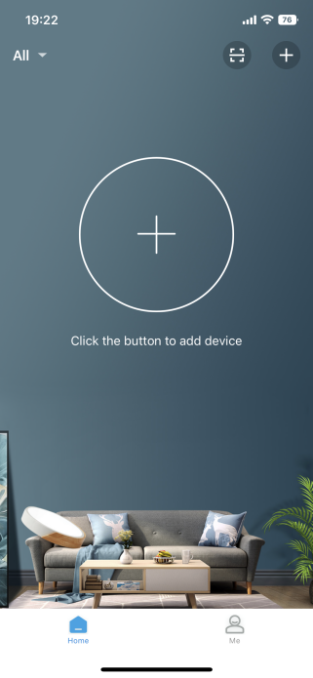 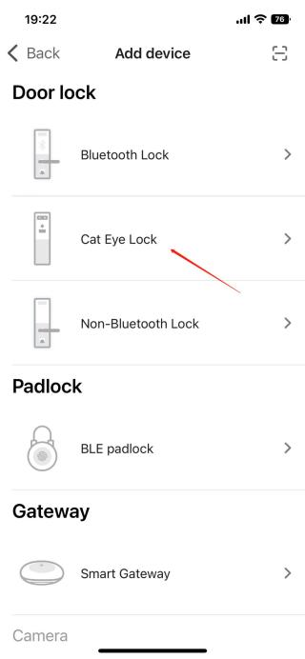

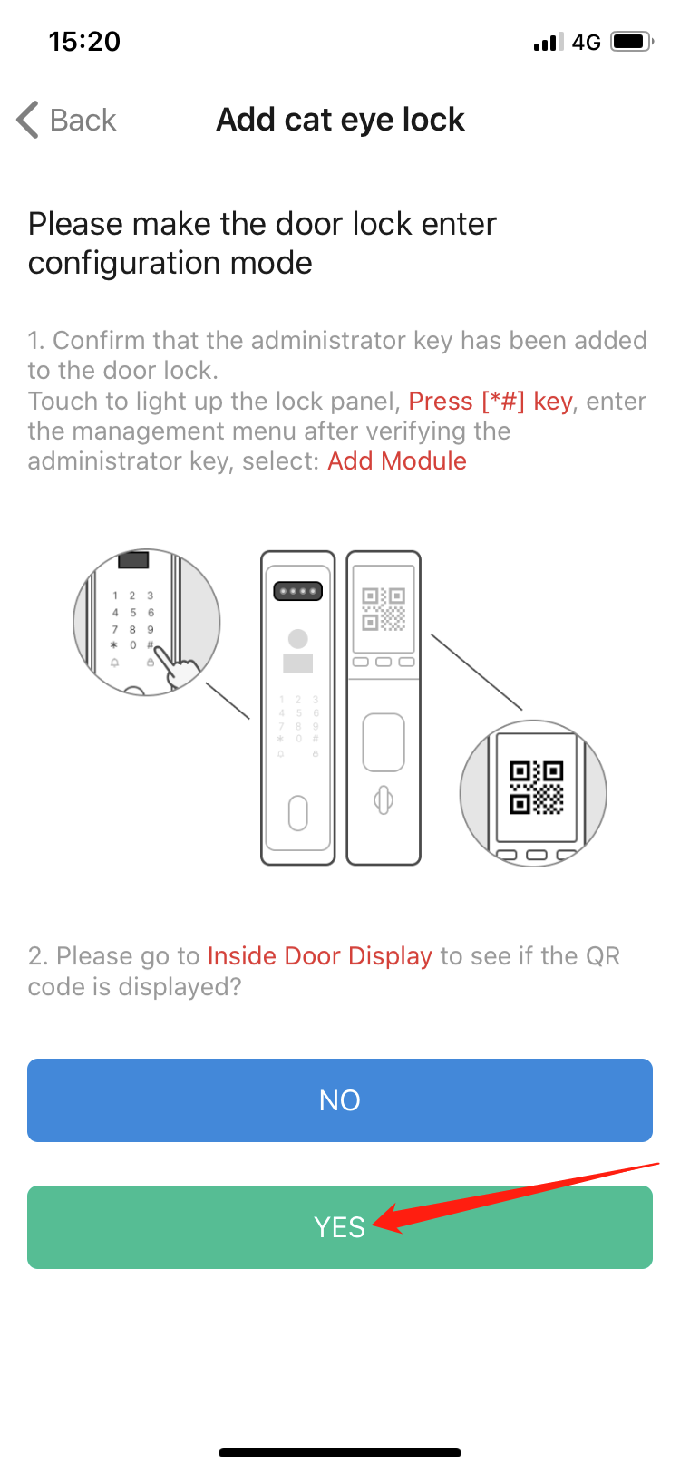

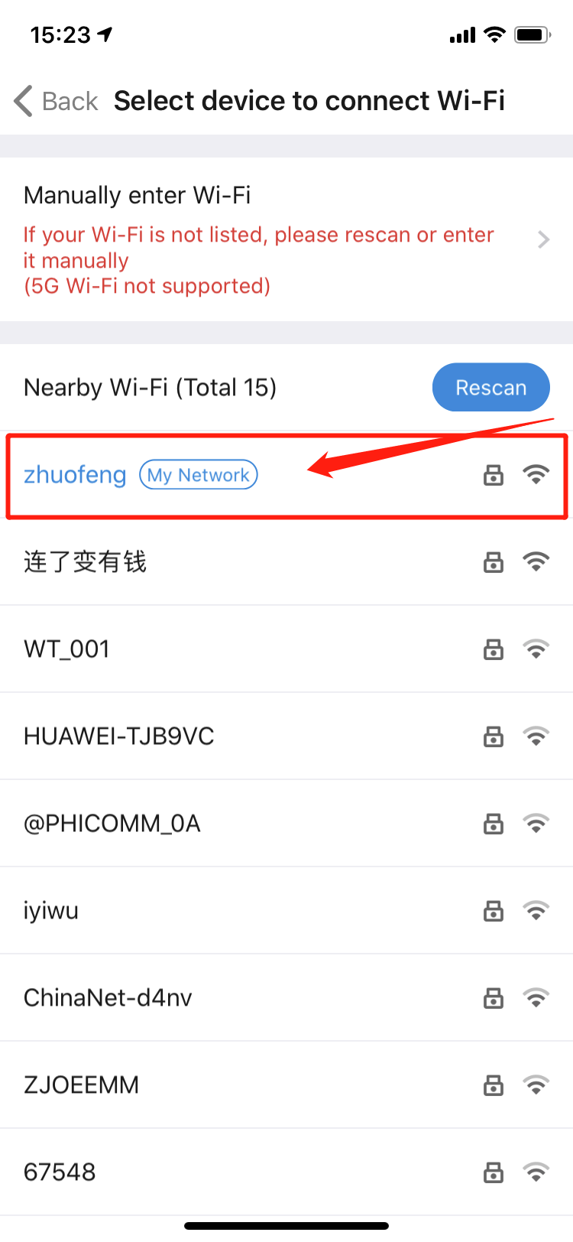 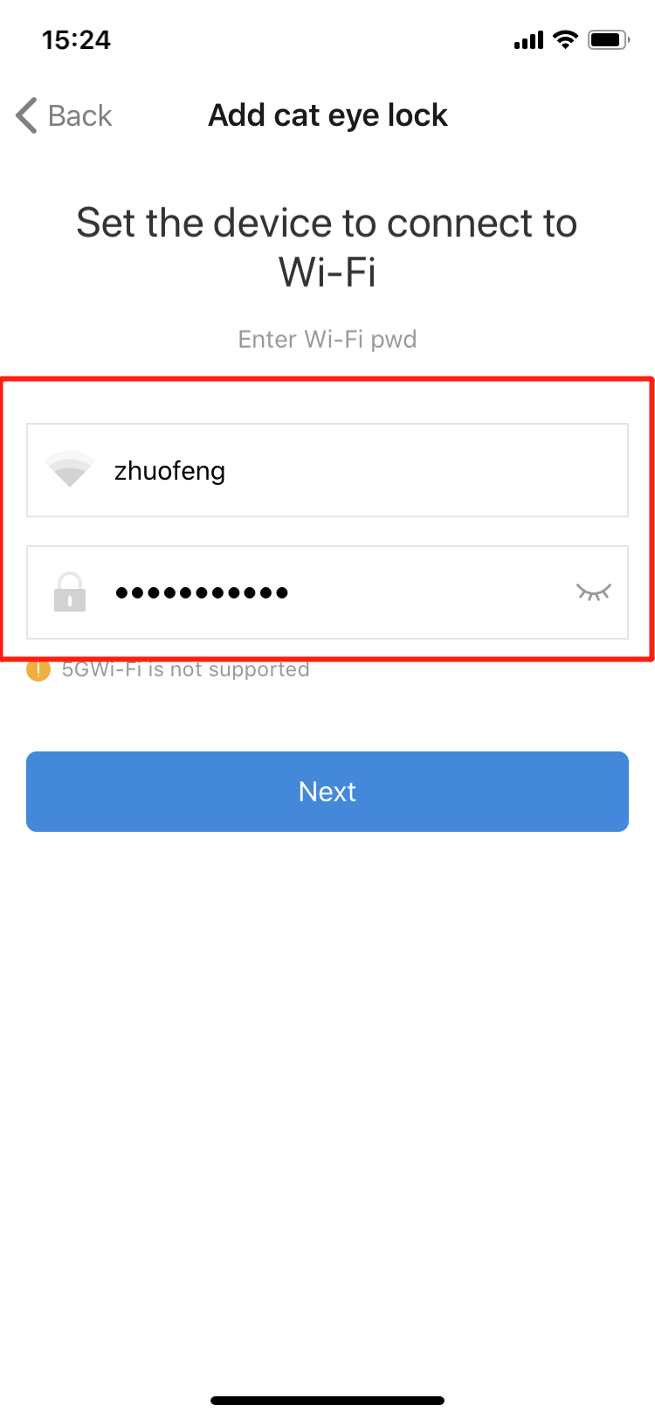 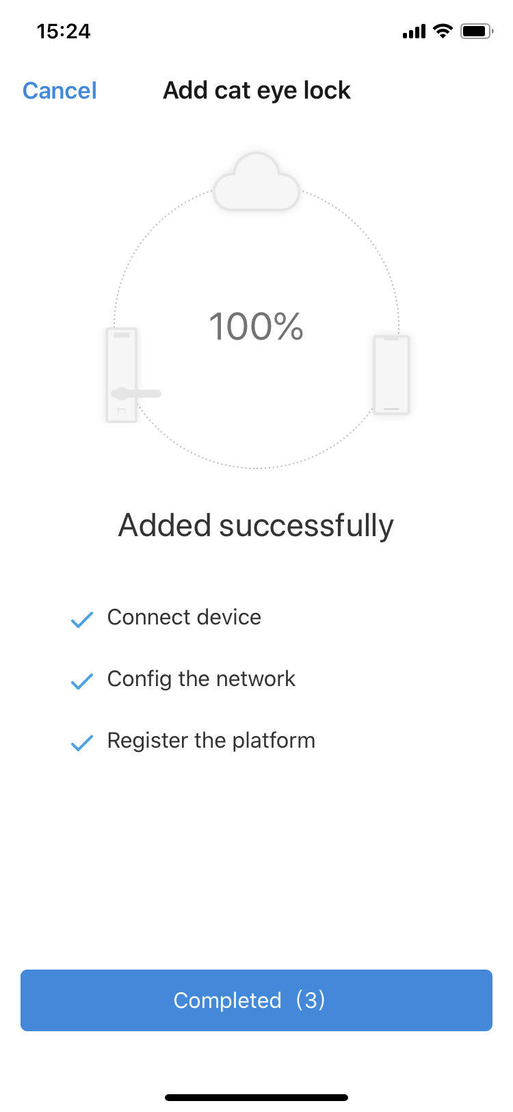

**6.1. APP Remote Unlock ( WIFI Connect Version)**

1) Download “Wishome” from App store(ios)/Download “WiShome” from google play(Android)



2)User registration/login. For the first time, you need to register a user, enter a mobile phone number or email address to register users; If have account,user can login in directly .

3)After logging in, click “ADD”---”Add Wi-Fi Device”

 

3)Back to the lock Enter “*” and “#”→enter administrator authentication(face/password/card/fingerprint) →Press2.App setting→ Press 1.Add module → Then connect wifi named “CloudHome Plus C8C9A.....” in your cellphone.

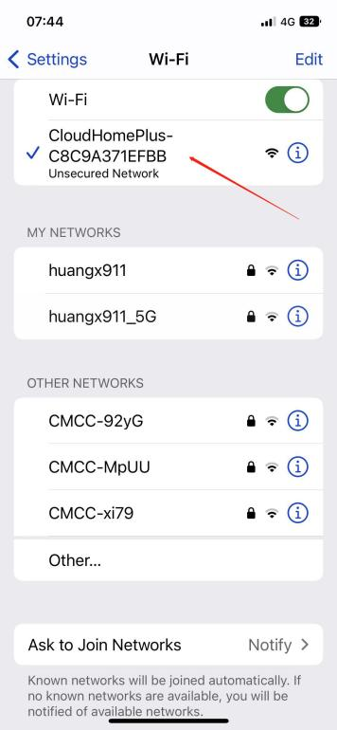

4)Back to Wishome app,waiting for adding device.....

